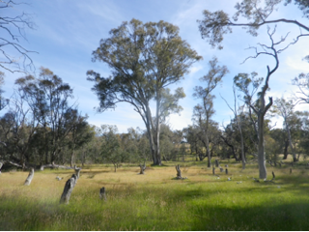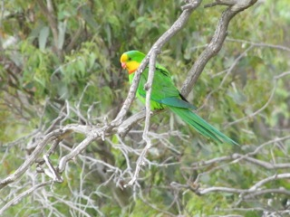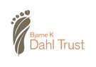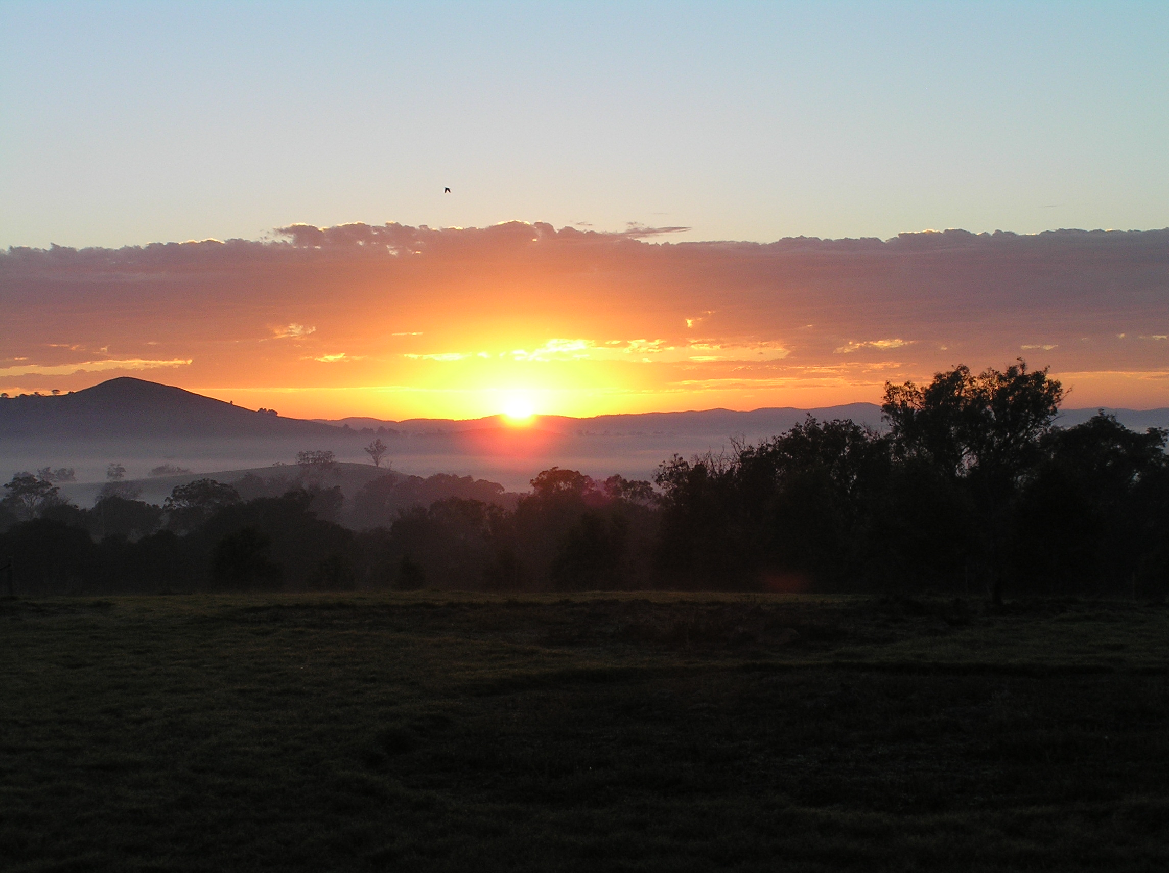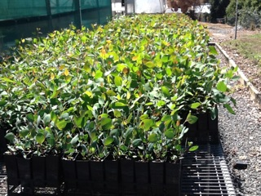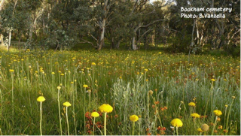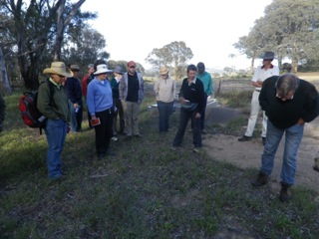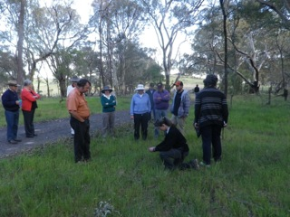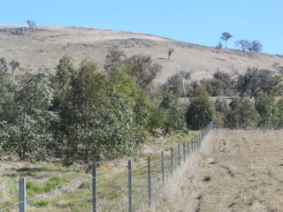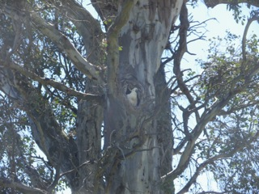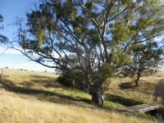

## Cobbler Road Fire Spurs Landcare Group

April 2014

December 2013

Eucalypt seedlings ready for distribution.

Seeds for 11,000 eucalypt seedlings planted at the Group’s propagation day.

$15,000 grant received from the Bjarne K Dahl Trust for eucalypt propagation

October 2013

Bowning & Bookham Districts Landcare Group Formed

May 2013

Cobbler Road Fire destroys property and livestock in Bookham and Bowning

January 2013

## Past Events

#### 11,000 seedlings for bushfire remediation

The Bowning and Bookham Districts Landcare Group was formed in 2013 to foster land conservation in the area surrounding the towns of Bowning and Bookham in the Southern Tablelands

…see pg2

Funding from the Bjarne K Dahl Trust for propagation of eucalypts will see the establishment of a bank of seedlings available for property remediation following the Cobbler Road bushfire.

The Bowning and Bookham Districts Landcare Group is a small group of volunteers working together to promote sustainable land management.

The group was formed in 2013 after the Cobbler Road bushfire destroyed thousands of acres of farmland and bush.

With the help of the Bjarne K Dahl Trust for eucalyptus education, promotion, establishment, cultivation and conservation, the Group has established a bank of 11,000 eucalypt seedlings for remediation of bushfire-affected properties.

The Group conducts various other activities related to land, plant and wildlife conservation, and will continue to expand these activities in the district.

lorem ipsum dolor

Winter 2014

Autumn 2014

Bowning & Bookham Landcare Group

5,500 eucalypt seedlings are looking for new homes, and there’s more to come.

The Bowning and Bookham District Landcare group was formed in 2013 in response to last year’s Cobbler Road bushfire which destroyed thousands of acres of farmland and bush. The group’s first priority was to help landowners remediate their land in a sustainable and economic way.

With the help of a grant from the Bjarne K Dahl Foundation for eucalypt education, promotion, establishment, cultivation and conservation, the small group of volunteers has established a bank of 11,000 eucalypt seedlings for remediation of bushfire-affected properties.

5,500 mature and hardened eucalypt seedlings are now ready to be distributed to properties affected by bushfires. The Landcare group wants to hear from property owners interested in getting the native trees going on their land. Seedlings will be provided free of charge, along with glysophate for area preparation if required. The group may also be able to coordinate volunteers to help plant the trees.

District landowners affected by bushfires are now encouraged to contact the Bowning and Bookham Districts Landcare group to discuss the distribution of the first batch of seedlings. Please contact the group Secretary Kathryn Mcguirk at [kangiara@gmail.com](mailto:kangiara@gmail.com) or the Chairman Alan Cole on 0418852209.

## 11,000 Seedlings for Bushfire Remediation

The Bjarne K Dahl Trust focuses on eucalypts, an Australian icon and a significant aspect of Australia’s natural environment and biodiversity.

##### The Bjarne K Dahl Trust was established from a bequest by Bjarne Dahl, a Norwegian Forester, who developed a true affinity with the Australian bush, and a particular love for the Silvertop Ash, Eucalyptus Sieberi and left his entire estate to establish the Trust.

# Bjarne K Dahl Trust

The Australian Red Cross turns 100 this year and the Bookham and Berremangra Branch turns 75.

To celebrate, a lunch will be held at Bookham Memorial Hall on Red Cross Foundation Day, Wednesday, 13th August. Two commemorative Red Cross roses will be planted on the day. There will also be a Century of Fashion event held on Saturday 13th September.

Further details of these will be provided in the Yass Tribune closer to the time.

Landcare was formed in 1989 with a partnership between the National Farmers’ Federation, the Australian Conservation Foundation and the federal Government. Since then, Landcare has grown into the national movement of today that brings together individuals and groups to focus on making Australia a better and more sustainable place to live.

25 Years of Landcare



The Bowning & Bookham Landcare Group meets on the third Thursday of the month at the Bowning Hotel or Barney’s of Bookham. 6:30pm for dinner, followed by the meeting at 7:15pm.

Bowning & Bookham District Landcare Group

Red Cross Celebrations

## Saving Box Woodlands

##### The National Register of Big Trees has been established by a community-minded individual in Australia who has worked closely with Federal and State Forestry & Environmental Departments and related entities, such as National Parks, that have interests that parallel with the Objectives of the Register. http://www.nationalregisterofbigtrees.com.au

# National Register of Big Trees

Subsequently, the National Register of Big Trees determined that we had found the largest Blakeley’s Red Gum in NSW.

This was a great start for the new Group. The Group now invites landholders and other Landcare groups to challenge this beauty.

For further information, please contact the Landcare Group Secretary, Kathryn McGuirk at [kangiara@gmail.com](mailto:kangiara@gmail.com) or call the Chairman Alan Cole on 0418852209.

The Bowning and Bookham Districts Landcare Group and Murrumbidgeee Landcare Incorporated held a workshop on May 10th at the Bookham Hall on the regeneration of the Yellow Box and Blakeley’s Red Gum woodlands.

Keynote speakers addressed:

* Rural tree decline and the Dahl Trust revegetation programme

The ecological significance of the Yellow Box and

* Blakeley’s Red Gum vegetative communities
* The value of remnant trees to fauna survival.
* Projects to regenerate Box woodlands

There was also a walk through the iconic Bookham Cemetery.

If you would like to attend future land management workshops, we would welcome you to join the Bowning and Bookham Districts Landcare Group.



At the first Bowning and Bookham Districts Landcare Group Christmas get together at a member’s property South of Bowning, the group experimented with different techniques for measuring trees, seeking contenders for the National Register of Big Trees.

Three measurements were required: the height, the girth of the tree 1.4m from the ground and the spread of the tree canopy.

Our contenders were a couple of Blakeley’s Red Gums. One had a height of 26 m, a circumference of 6.2m and a canopy diameter of 29m.

Subsequently, the National Register of Big Trees determined that we had found the largest Blakely’s Red Gum in NSW.

This was a great start for the new Group. The Group now invites landholders and other Landcare groups to identify trees that may challenge this beauty.

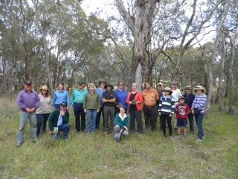

# Farm Five – Farm Risk Management

Well maybe; but what if we employ a staff member, a family member or a contractor?

What then, they won’t have the benefit of our 40 years of experience, they may be new to farming and they may not know where that old well is, or where those drains run or where you slung that hotwire last week!

How should we manage farm risk? After all we do have both a legal and moral duty of care to provide a safe place and system of work for our farm staff, our family staff and our contractors. Part of that duty of care is to share our knowledge of the farm hazards and the farms risks.

We can share that knowledge in conversation and that works fine until something goes terribly wrong! Another alternative is to develop a whole of farm **Risk Register** to provide to and discuss with our farm staff, family staff and contractors, and that’s a great idea but where and how do I start. Well one way to start is with a **Farm Five**. A **Farm Five** requires five minutes of consideration by you and your staff of the job steps and the associated risks of those steps. Try it out on any unusual job you may need to do, or with a contractor you have never dealt with before. You should aim to do it before all the tasks you do on the farm if you are employing staff or contractors.

The following image shows how it works.

As farmers we take on risk every day, it’s no big deal, we mentally weight up the pros and cons, the likelihood and consequence and just get on with it in the safest possible way that is reasonably practical, after all we have survived on the farm for over 40 years. Right?

Continued from page 6

Make sure you sign off the document when you finish discussing it with your staff. By going through this process over a range of farm jobs you will soon develop a risk profile for your farm and the jobs you do on your farm, and then we can help you develop a **Risk Register**.

Keep Safe,

Alan Cole

Chair BBDLG

Well maybe; but what if we employ a staff member, a family member or a contractor?

What then, they won’t have the benefit of our 40 years of experience, they may be new to farming and they may not know where that old well is, or where those drains run or where you slung that hotwire last week!

How should we manage farm risk? After all we do have both a legal and moral duty of care to provide a safe place and system of work for our farm staff, our family staff and our contractors. Part of that duty of care is to share our knowledge of the farm hazards and the farms risks.

We can share that knowledge in conversation and that works fine until something goes terribly wrong! Another alternative is to develop a whole of farm **Risk Register** to provide to and discuss with our farm staff, family staff and contractors, and that’s a great idea but where and how do I start.

Well one way to start is with a **Farm Five**. A **Farm Five** requires five minutes of consideration by you and your staff of the job steps and the associated risks of those steps. Try it out on any unusual job you may need to do, or with a contractor you have never dealt with before. You should aim to do it before all the tasks you do on the farm if you are employing staff or contractors.

The following image shows how it works.

The process is pretty straight forward, document the job step, any hazards associated with that step, the control measures used to address those hazards and estimate the residual risk rating to determine if it is acceptable. If a residual risk rating is **High** or **Extreme**, well that should flag that the task is an unacceptable risk to your farm business and you will need to work out a different way of doing things!

How do I work out **Consequence**, **Likelihood** and **Residual Risk**? Well BBDLG have made it easy, just look up the following easy to use **Risk Matrix** to calculate the risk associated with the steps of the job you are about to take on.

#### Bowning Hall

Seed Collection Workshop

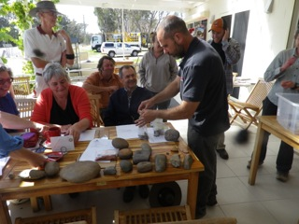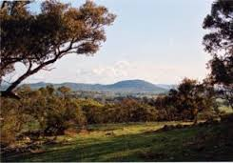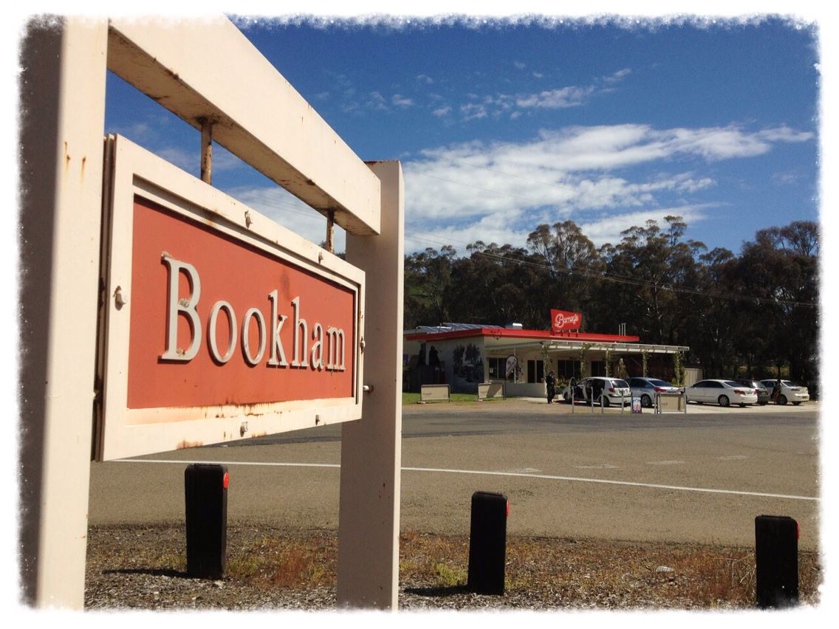

Bowning Lions Club

The Bowning Lions Club meets regularly at locations between Yass, Binalong and Bookham. If you would like to find out more about Lions clubs access: <https://directory.lionsclubs.org/>

Yass Citizen of the Year

Bookham community has a range of interesting activities over the year.

The next event is a Trivia Night to be held at Bookham Memorial Hall on Saturday 24th May. People interested in joining in should contact Judy Ticehurst on 6227 7276.

Bookham Activities

Congratulations to the Bookham Cricket Team that participated in the Sweeney Cup competition through the cricket season. The team went on to win the grand final and is now the proud holder of the cup.

Bookham Cricket

The Bowning Hall hosts a number of activities throughout the year some of which include regular auctions, Zumba dance classes on a Tuesday and Thursday night. The Fleeced in Bowning wool group also meets in the rooms behind the Hall. If you would like to hire the hall or find out when the next auction is on please contact Joyce on 62276041.

41 students are enrolled at the Bowning Primary School for 2014. Already this year, children have participated in swimming and cross-country carnivals, plus a range of musical activities. The school has a $15 Bowning Recipe Book available from the School Office. If you would like to learn more about the happenings at the Bowning Primary School please ring the office on 62276093. Alternatively if you would like to join the Bowning P&C please contact the President Marnie Pack.

Bowning School

CONGRATULATIONS to Bookham farmer, Doug Painting, who was named 2013 Yass Citizen of the Year on Australia Day this year. Doug was also a state finalist in the Australian of the Year for 2013 in the Local Hero category.

Doug worked tirelessly during and after the Cobbler Road Fire that swept through the region in January 2013 and liaised with Yass Valley Council and Harden Shire Council to get a BlazeAid camp set up in the Bookham Memorial Hall.

Over many years, Doug has been a stalwart of the Bookham community, providing support to people with a disability, restoring the St Clement’s Church, helping with various community infrastructure projects and he has further contributed to the community through membership of Bowning Lions Club, the Bookham Agriculture Bureau, Bookham Rural Fire Brigade and the Binalong Rescue Squad.

The Bowning and Bookham Landcare Group conducted a native tree seed collection workshop at Grace’s Flat in December. A repeat workshop is planned for May, and may take place at the historic and environmentally important Bookham Cemetery and the adjacent travelling stock route reserve.

Contact the Secretary Kath Mcguirk at [kangiara@gmail.com](mailto:kangiara@gmail.com) or the Chairman Alan Cole on 0418852209 for more information.

Wally and Tyronne Bell from Thunderstone joined the group and spoke about aboriginal activities in this region. They encouraged the group to notify their group if possible artefacts are found on our properties. A scar tree was viewed and estimated to be very, very old based on the size of the healing wounds surrounding the removed bark.

Stone tools, stone cores and spear heads were shown to the group at Barney’s café after the meeting.

#### Thunderstone Land Services

On Saturday 2 November Nicki Taws from Greening Australia and 16 members of the BBLCG met at the Bookham cemetery to undertake a wildflower / native plant / bird walk. Nicki pointed out a number of species of plants and birds. The cemetery is within a fine example of native woodland.

#### Visit to Bookham Cemetery

Anglican Church

Bookham croquet club plays at the Bookham cricket ground on the first and third Sundays in the month (weather permitting). New participants welcome. Times vary depending on daylight saving and how hot or cold the weather is. Some days we meet at Barney’s cafe first, for lunch or afternoon tea. Contact Bruce Hazell on 6227 7202 to find out the arrangements for the next croquet day.

Croquet

Bowning RFS Captain

Do you know who the Bowning Bush Fire Brigade Capitan is? It’s now Sam Kelly.

Sam recently returned to Bowning and has taken over the key role. Sam has provided the following statistics on callouts by the Brigade volunteers over the last twelve months:

* There were four general call outs
* One structural fire
* Nine grass, car or other types of fire

Volunteers also attended one out of area task force.

This was a relatively large number of callouts for a volunteer group.

If you would like to learn more about the Bowning Bush Fire Brigade, contact Sam Kelly on 0427 276 140. Alternatively you could introduce yourself to existing volunteers at the monthly training night held on the 1st Monday night of each month from 7.00pm at the Bowning Bush Fire Brigade station in Leake Street.

The Bowning Antique Centre is located next to the Bowning Pub in Leake Street. This centre has an extensive range of antiques and collectables that includes china, crystal and glass wear, jewellery, a massive record collection and quality antique and 20th century furniture. The centre is open Thursday to Sunday from 10am to 4pm and you can contact the centre on 6227 6527.

#### Antiques

A new homeware and nursery business opened in Bowing in March to a very wet welcome opening day. Mayfield Mews sells a range of seedling, plants large and small and a varied range of metal and pastel art pieces. The new business is open from Wednesday to Sunday, and the number of cars outside 4 Leake Street seems to have doubled.

#### Mayfield Mews

If you would like to attend a small unique country Anglican church there are two options the being All Saints at Tangmangaroo, Lachlan Valley Way with services on the 2nd Sunday of each month from 10.30am. The Easter service at All Saints at Tangmangaroo is scheduled for 7pm on Easter Sunday.

In Bowning, St James has monthly services on the 4th Sunday of each month at 10am followed by coffee at Roll on in Cafe. If you would like to enquire about either of these services please contact Bimbi on 0417 422193.

Bowning & Bookham Districts Landcare Group

PO Box 2026  
Bowning NSW 2582

Chair: Alan Cole 0418852209 alanpcole@bigpond.com

Secretary: Kath Mcguirk kangiara@gmail.com

#### Bowning Post Office

Edith at the Bowning post office and paper shop has lived in Bowning for as long as anyone can remember. Edith distributes all the local mail, and is a wealth of knowledge about the district. Edith sells local and regional newspapers, the necessities like milk, bread and sugar and lots of other things. For any type of postal service contact Edith at the Bowning Post Office rather than making the trip into Yass.

#### Barney’s of Bookham

Barney's Of Bookham is a locally owned and operated cafe with the freshest coffee and beverages, tasty snacks and a variety of dessert dishes that are sure to delight. When you want a **coffee on the Hume at Bookham**, we are the obvious choice.

Meet up with friends and enjoy a delicious hot drink in the winter, or a refreshing cold beverage in summer. Our friendly staff will make you feel right at home. Phone Darryl 0412 684 743.

Barney’s is a supporter of the Bowning & Bookham Districts Landcare Group.